|  |  |  |
| --- | --- | --- |
| Name | Saeed Mahmoud Saeed |  |
| B.N | 388 |  |
| Edu mail | Saeed195432@feng.bu.edu.eg |  |

* Title

Operation systems

* 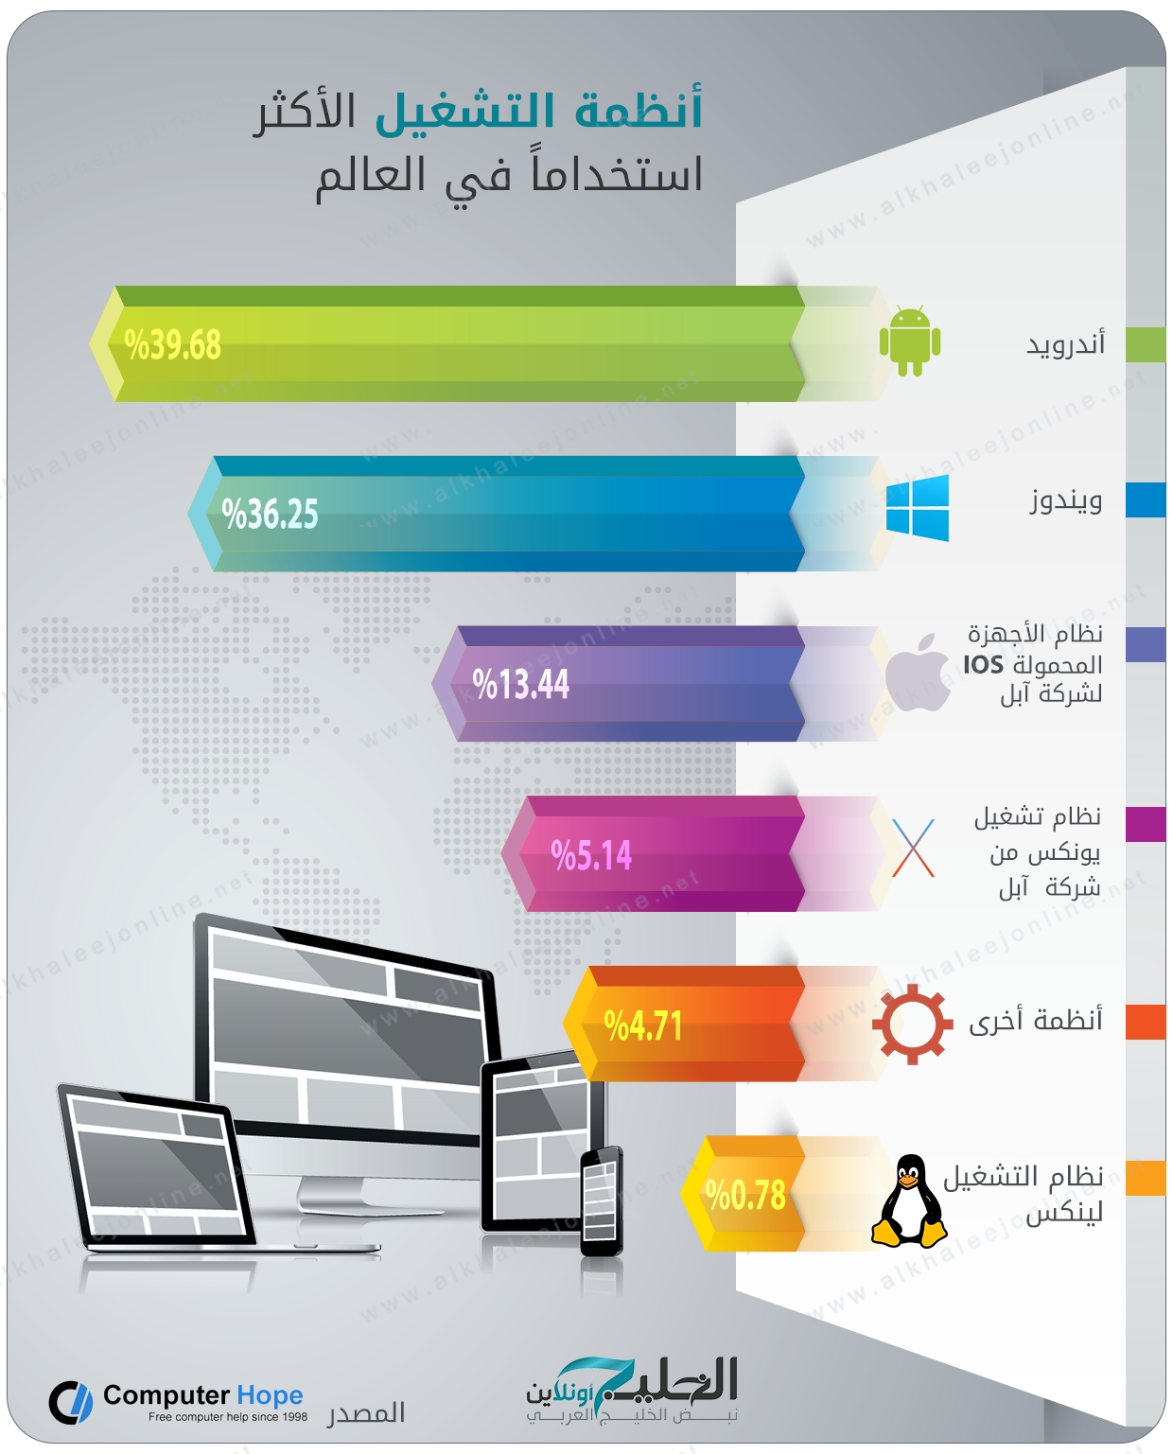Screenshots

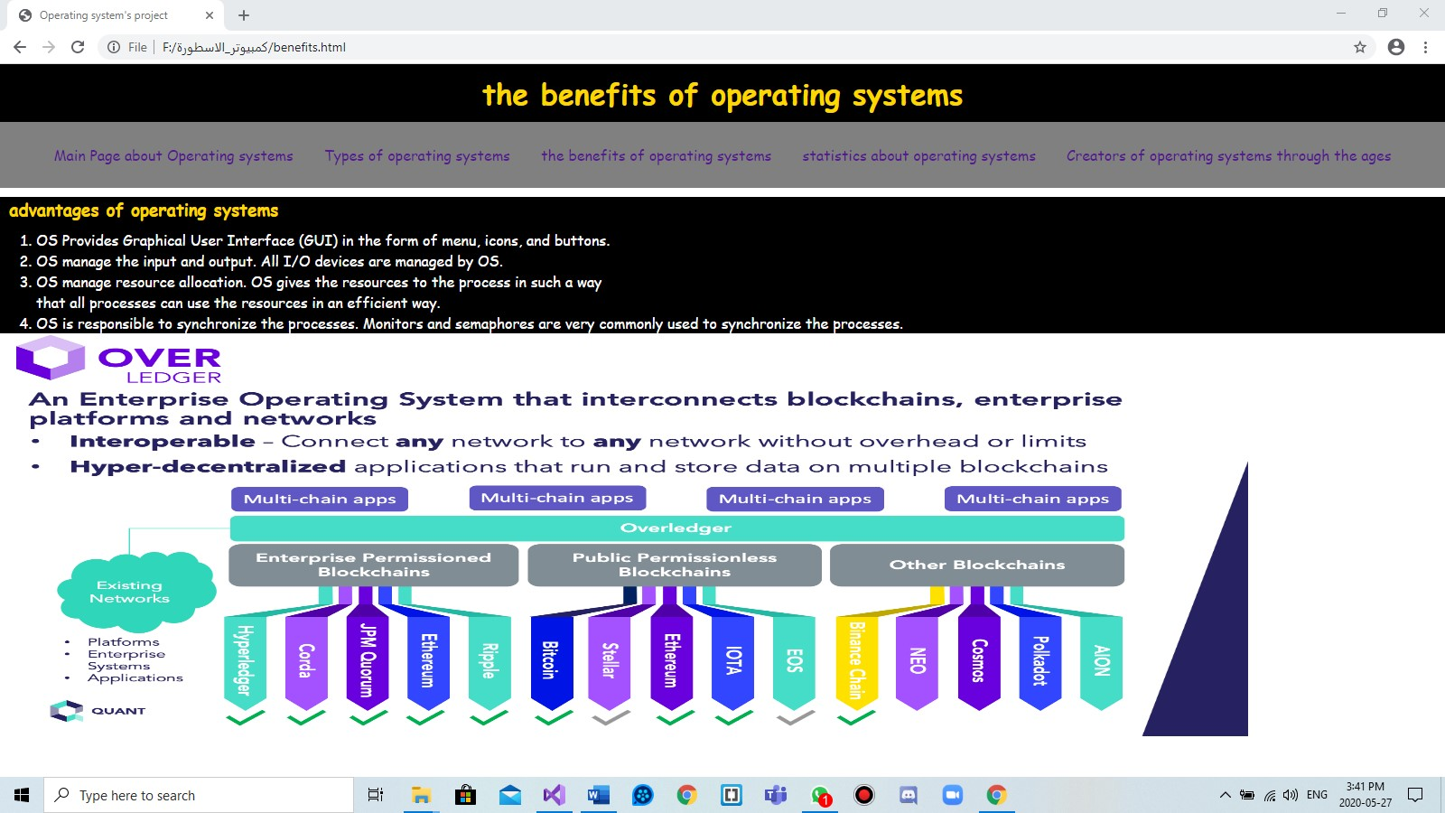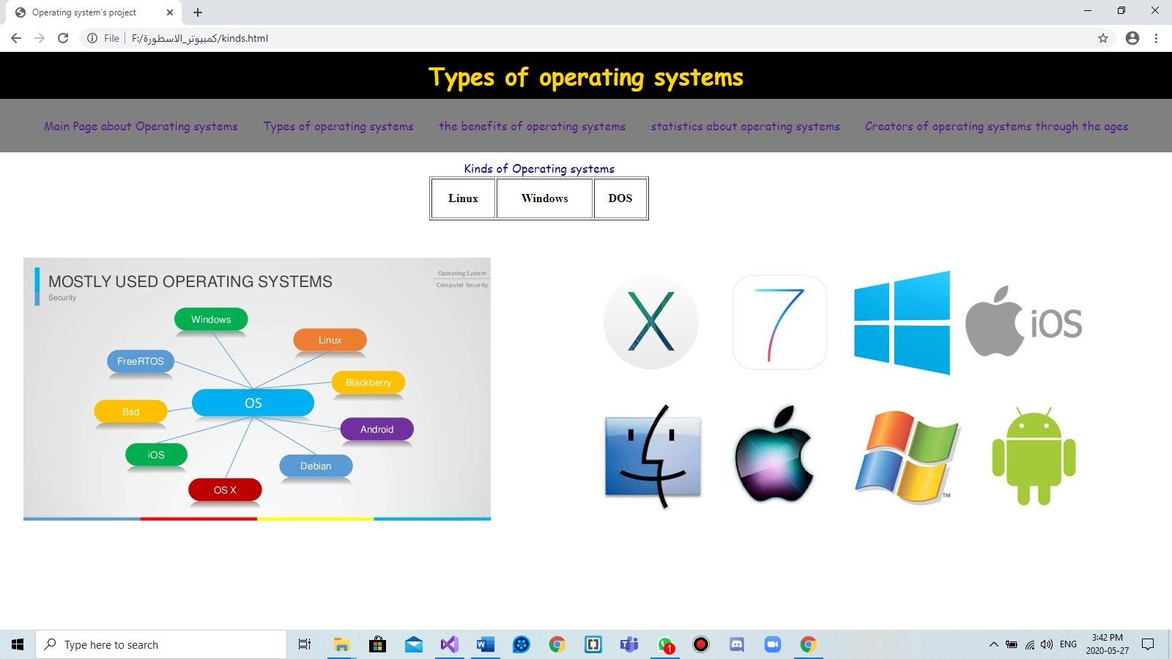

* Source code :

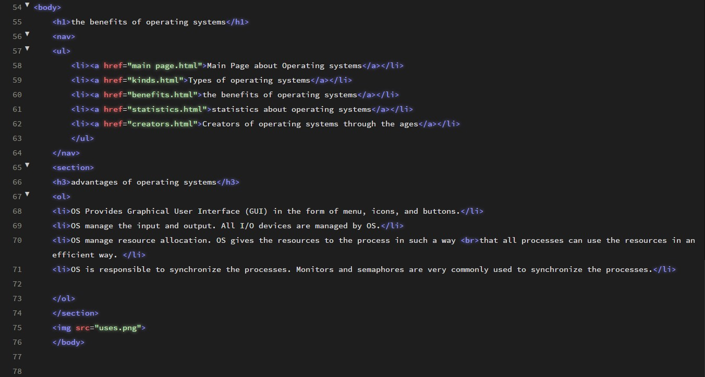

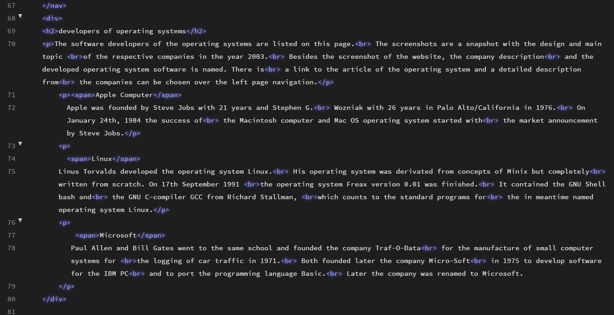

* Introduction
* **An operating system acts as an in intermediary between the user of computer and computer hardware**
* **.The purpose of an operating system is to provide an environment in which a user can execute programs in a convenient and efficient manner.**
* **An operating system is a software that manages the computer hardware. The hardware must provide appropriate mechanisms to ensure the correct operation of the computer system and to prevent user programs from interfering with the proper opera toing of the system.**
* **• An operating system is a program that controls the execution of ap application programs and acts as an interface between the user ofa computer and the computer hardware.**
* **A more common definition is that the operating system is the one program running at all times on the computer (usually called the kernel), with all else being apply cation programs.**
* **An operating system is con corned with the allocation of resources and services, such as memory, processors, devices, and information. The operating sys tem correspondingly includes programs to manage these resources, such as a traffic controller, a scheduler, memory management module, I/O programs, and a file** system.